**RIT Dubai**

**Spring 2025**

**LAB4/** **DHCP Starvation & DNS Poisoning**

| **Name** | **ID** |
| --- | --- |
| Suhaila Alfalasi | 764005288 |
| Rania Kanaan | 769007321 |
| Fatima Rabiu | 776006447 |
| Syed Shayan Ali | 393003651 |

**Objectives:**

In this lab DHCP starvation and DNS poisoning attack are performed to allow the attacker to act as Man In The Middle (MITM) by setting a Rogue DHCP server that redirects the client to a faked DNS server. This Faked DNS server redirects the client to a phishing website.

**Deliverables and Rubrics:**

1. The report is appropriately organized with suitable objectives and structure. The organization of the report should be as follows: (15%).
   1. The cover page contains Lab general information, Group information, and Rubrics.
   2. Objectives and goals of this lab
   3. Attack steps with detailed discussion and observation.
   4. Problems faced in the lab
   5. Conclusion and references. Full citation of each statement you referenced is very important.
2. The report provides all the figures and screenshots that demonstrate the steps of the attack associated with the discussion and a clear explanation of related concepts on which the attack is based. The network architecture (router, switches, attacker, and other PCs) should be presented. (35%)
3. The report explains the tests that were carried out to verify that the attack was successful. (20%)
4. The report illustrates the solutions and the troubleshooting steps taken. (5%).
5. The report clearly specifies the mitigation steps that have been carried out to prevent the attack and explains how these steps prevent the attack. (25%). (at least 2 approaches need to be implemented)

**TABLE OF CONTENTS**

**OBJECTIVES**

**TOPOLOGY & ARCHITECTURE**

**SOFTWARE/TOOLS USED**

**INITIAL CONFIGURATIONS**

Network Configurations

Apache HTTP Web Service Configurations

**ATTACK DESCRIPTION**

**STEPS OF ATTACK**

Basic Steps

Attack Implementation

**PROBLEMS/ISSUES FACED**

**MITIGATION TECHNIQUES**

Port Security

DHCP Snooping

IP Source Guard

Implementing IEEE 802.1X

**CONCLUSION**

**REFERENCES**

# OBJECTIVES

The objective is to allow an attacker to act as a Man in the Middle (MITM) by setting up a rogue DHCP server. This rogue DHCP server redirects clients to a fake DNS server. Additionally, this fake DNS server redirects clients to a fake website.

The following objectives needs to be taken into consideration:

1. Designing a network architecture to plan the attack
2. Setting up a rogue DHCP server using Yersinia and Metasploit
3. Setting up a fake DNS server using Yersinia and Metasploit
4. Setting up a phishing website using Social Engineer Toolkit

# TABLE OF FIGURES & TABLES

| **Figure #** | **Title** | **Page #** |
| --- | --- | --- |
| Figure 1 | Topology | 6 |
| Figure 2 | Gateway IP addresses | 9 |
| Figure 3 | Router IP addresses Brief | 9 |
| Figure 4 | DHCP pool | 11 |
| Figure 5 | Update and Upgrade | 11 |
| Figure 6 | Git Cloning Yersinia | 12 |
| Figure 7 | Installing Libraries for Yersinia | 13 |
| Figure 8 | Automating the Build Process | 13 |
| Figure 9 | Compiling the Software | 14 |
| Figure 10 | Starting the Yersinia | 14 |
| Figure 11 | Sending Discover Packets | 15 |
| Figure 12 | DHCP IP Addresses being Depleted | 16 |
| Figure 13 | DHCP Spoofing | 19 |
| Figure 14 | Clearing IP DHCP Binding | 20 |
| Figure 15 | DHCP Rogue Server Using Ettercap | 21 |
| Figure 16 | Verification of the Attack | 22 |
| Figure 17 | Running setoolkit | 23 |
| Figure 18 | Site Cloning | 24 |
| Figure 19 | Using Server IP Address to a fraud website | 25 |
| Figure 20 | Verification of the Site Cloning | 25 |
| Figure 21 | Metasploit fakedns | 26 |
| Figure 22 | Mitigation of DHCP Starvation Attack | 28 |
| Figure 23 | Verification of the Mitigation | 28 |
| Figure 24 | Mitigation of DHCP server spoofing attack | 30 |
| Figure 25 | Verification of the Mitigation | 30 |

# 

# TOPOLOGY & ARCHITECTURE

The following diagram shows the topology of the LAN for the execution and testing of this Lab:

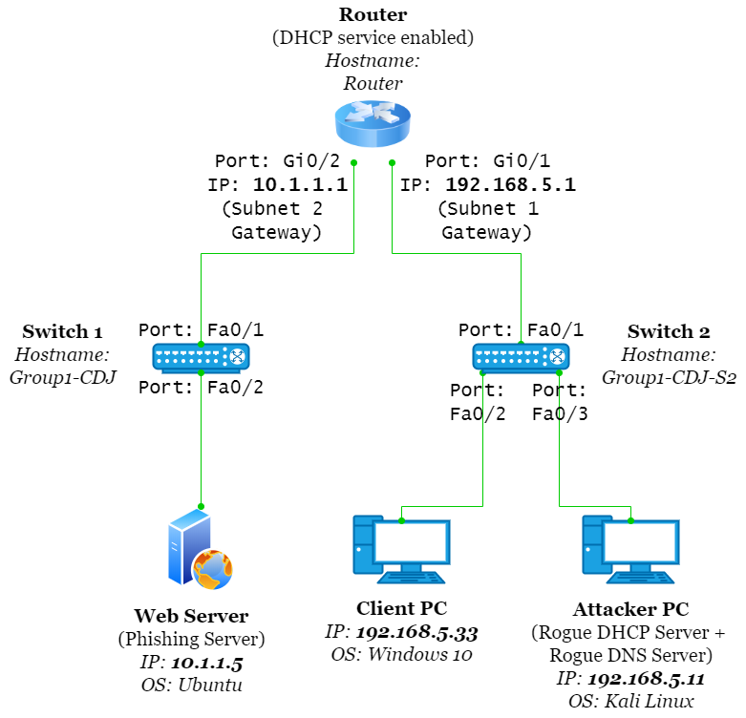

**Figure 1: Topology**

The topology consists of two networks which are connected to the router. In the first network, **Apache** Web Server (10.1.1.5/24) is connected to Switch 1. The second network (192.168.5.0/24) consists of the Client PC and the Attacker PC, both of which are connected to Switch 2, as can be seen in Figure 1.

# SOFTWARE/TOOLS

1. PuTTY
2. Metasploit Framework msfconsole
3. Yersinia - “Yersinia is a low-level protocol attack tool useful for penetration testing. It is capable of many diverse attacks over multiple protocols, such as becoming the root role in the Spanning Tree (Spanning Tree Protocol), creating virtual CDP (Cisco Discovery Protocol) neighbors, becoming the active router in a HSRP (Hot Standby Router Protocol) scenario, faking DHCP replies, and other low-level attacks,”. In the lab, the Yersinia toolis used to carry out the DHCP Starvation attack and advertise the rogue DHCP server.
4. Apache HTTP Server – It is a free and open-source cross-platform web server software. A simple website needs to be developed to orchestrate a basic session hijacking scenario subsequent to the ARP cache poisoning attack.
5. The Social Engineer Toolkit (SET) - SET will be used to generate a webpage similar to a legitimate website for the phishing server.

# INITIAL CONFIGURATIONS

## Network Configurations

The network devices in the LAN needs to be configured to the networks 10.1.1.0/24 and 192.168.5.0/24 with the IP address configurations as follows:

| **NIC** | **IP ADDRESS** |
| --- | --- |
| Router Interface - Gi0/1 | 192.168.5.1 |
| Router Interface - Gi0/2 | 10.1.1.1 |
| Client PC - eth0 | 192.168.5.5 (from the legitimate DHCP server) 192.168.5.33 (Post-attack - from rogue DHCP server) |
| Attacker PC - eth0 | 192.168.5.11 (static) |
| Phishing Web Server - eth0 | 10.1.1.5 (static) |

**IP addresses of Network Devices**

* **Useful commands**

>reload

>show run

>show interfaces

>int fastethernet 0/1

>ip address 192.168.5.1 255.255.255.0

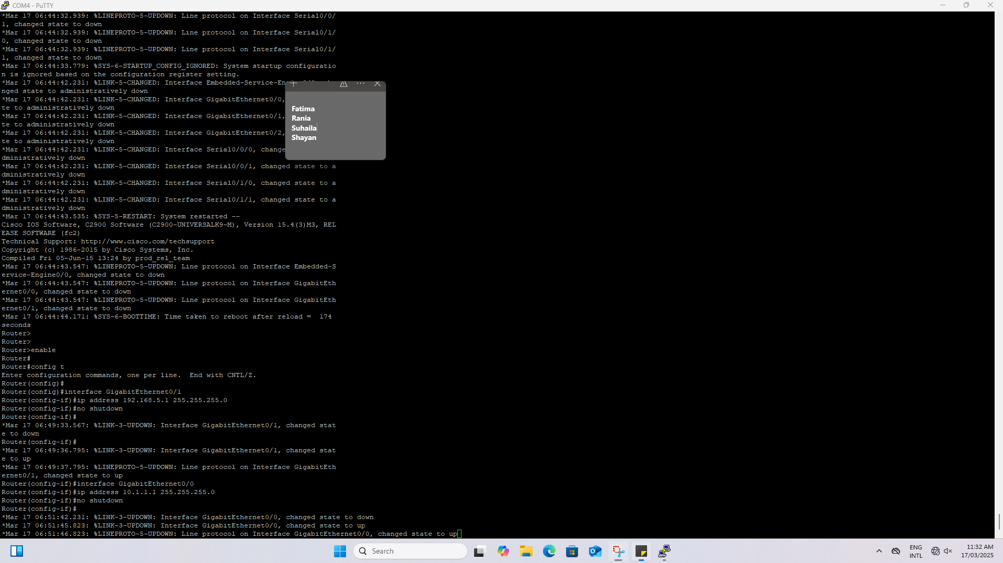

Figure 2. Gateway IP addresses

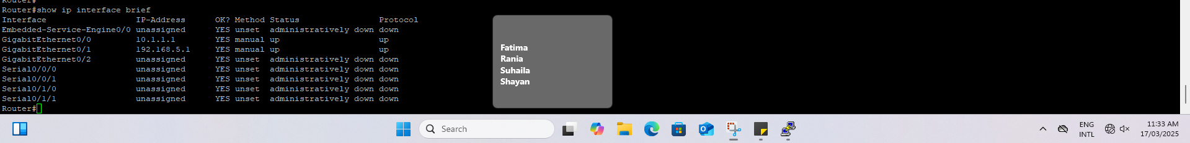

Figure 3. Router IP addresses Brief

* **To enable router’s DHCP service and create a DHCP pool**

**Other network do not need DHCP server as there is only 1 machine with a static IP.**

Once the client PC connects to the network and requests an IP from the DHCP server, it should be seen on the router pool information that 1 IP has been leased.

>show ip dhcp pool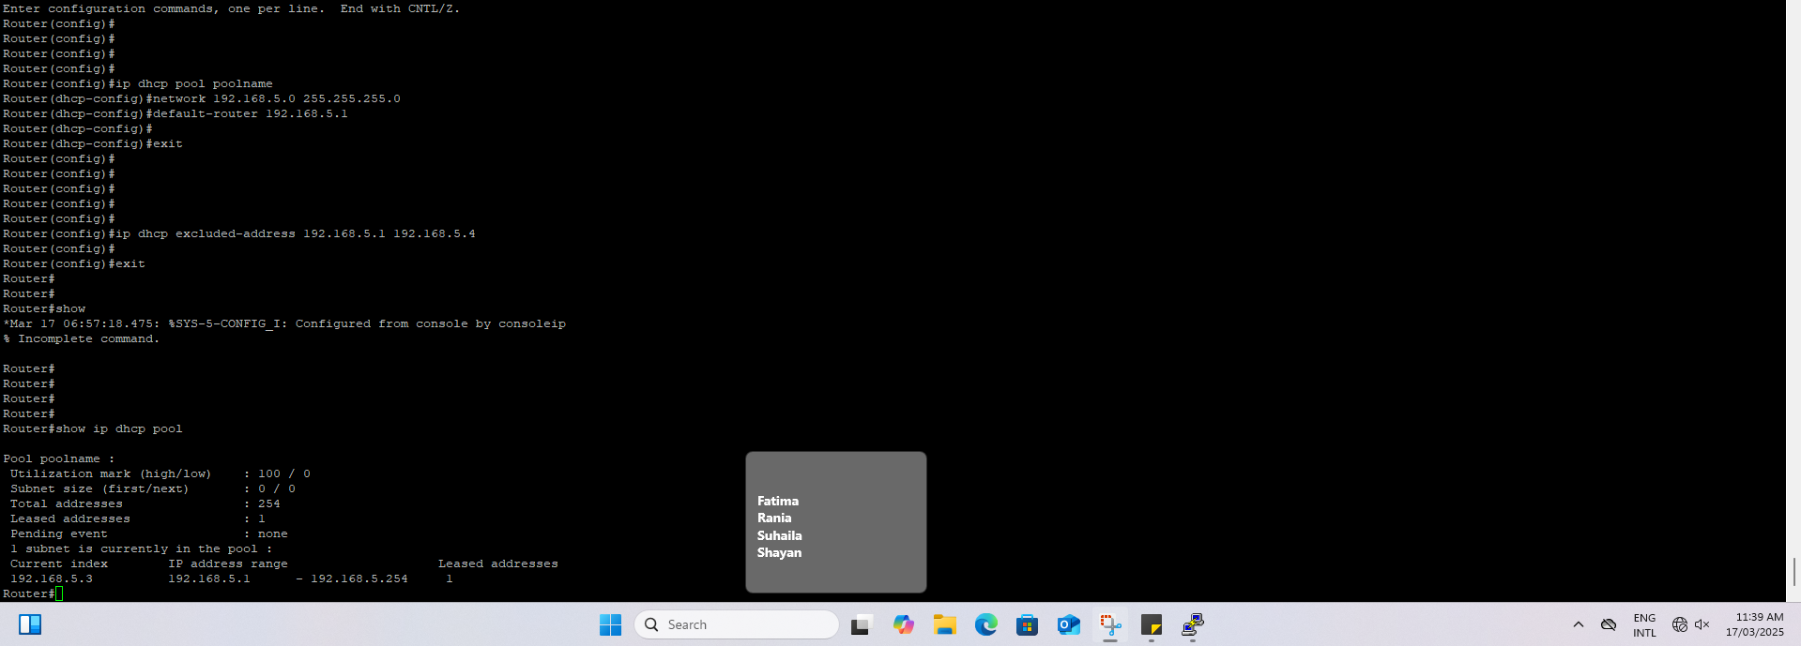

Figure 4. Show IP DHCP Pool

## Apache HTTP Web Service Configurations

The Apache HTTP web service needs to be configured on the phishing web server (10.1.1.5). Install the service and start it with below command.

>service apache2 start

>service apache2 status

# ATTACK DESCRIPTION

In step 1, DHCP starvation attack will be performed against router. The attacker broadcasts a large number of DHCP REQUEST messages with spoofed source MAC addresses. The DHCP Server in the network starts responding to all of these bogus DHCP REQUEST messages and available IP Addresses in the DHCP server scope will be depleted within a very short span of time.

In step 2, the attackers can then set up a rogue DHCP server and respond to new DHCP requests from network DHCP clients.

In step 3, attacker uses the rogue DNS server and deviates the end user traffic to fake web sites and launch phishing attacks.

# STEPS OF ATTACK

1. Turn on all PCs and ping to each other. Enable DHCP server in the router.

>conf t

>ip dhcp pool poolname

>network 192.168.5.0 255.255.255.0

>default-router 192.168.5.1

>exit

>ip dhcp excluded-address 192.168.5.1 192.168.5.4

(If you want, you can also exclude distribution of some IPs from the pool. See above)



Figure 4 . DHCP pool

Attacker is running the command show ip dhcp pool on router. Only one IP is leased. Shows that the attacker is controlling the dhcp pool.

1. DHCP Starvation Step
   1. On the Kali attacker machine, type:

> apt-get update

> apt-get upgrade

Figure 5. Update and Upgrade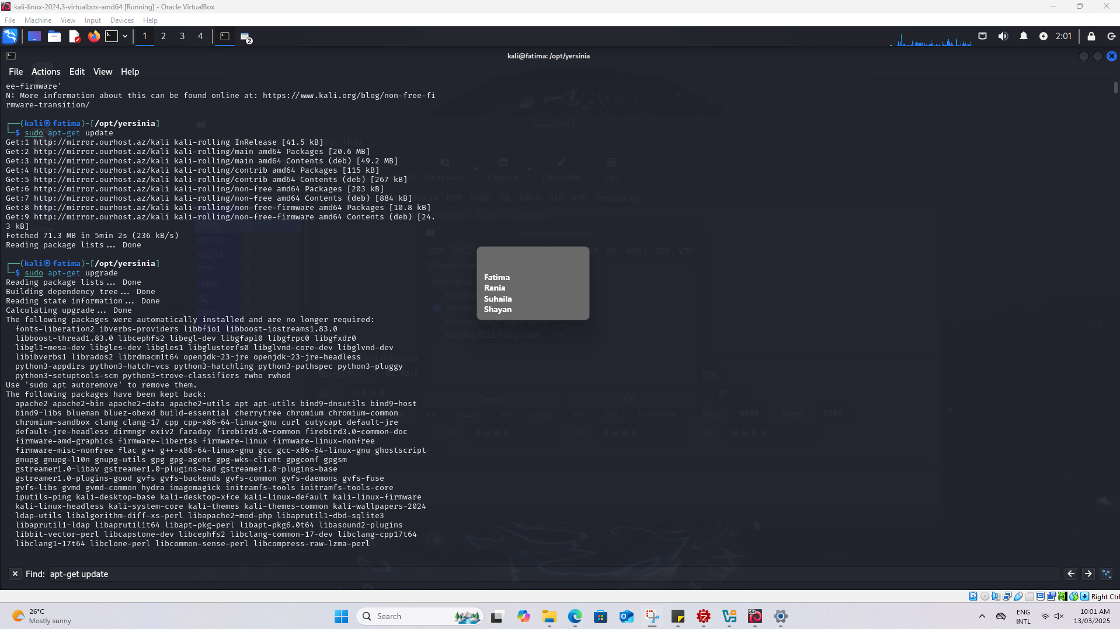

> sudo yersinia -G”.

If Yersinia was not installed before, you need to install. So type “Y” for auto installation. Even after installation, if you receive an error related to GTK, its because Kali has some problems with current version of Yersinia gui. There is a workaround for this current bug. Type:

>sudo git clone https://github.com/tomac/yersinia /opt/yersinia

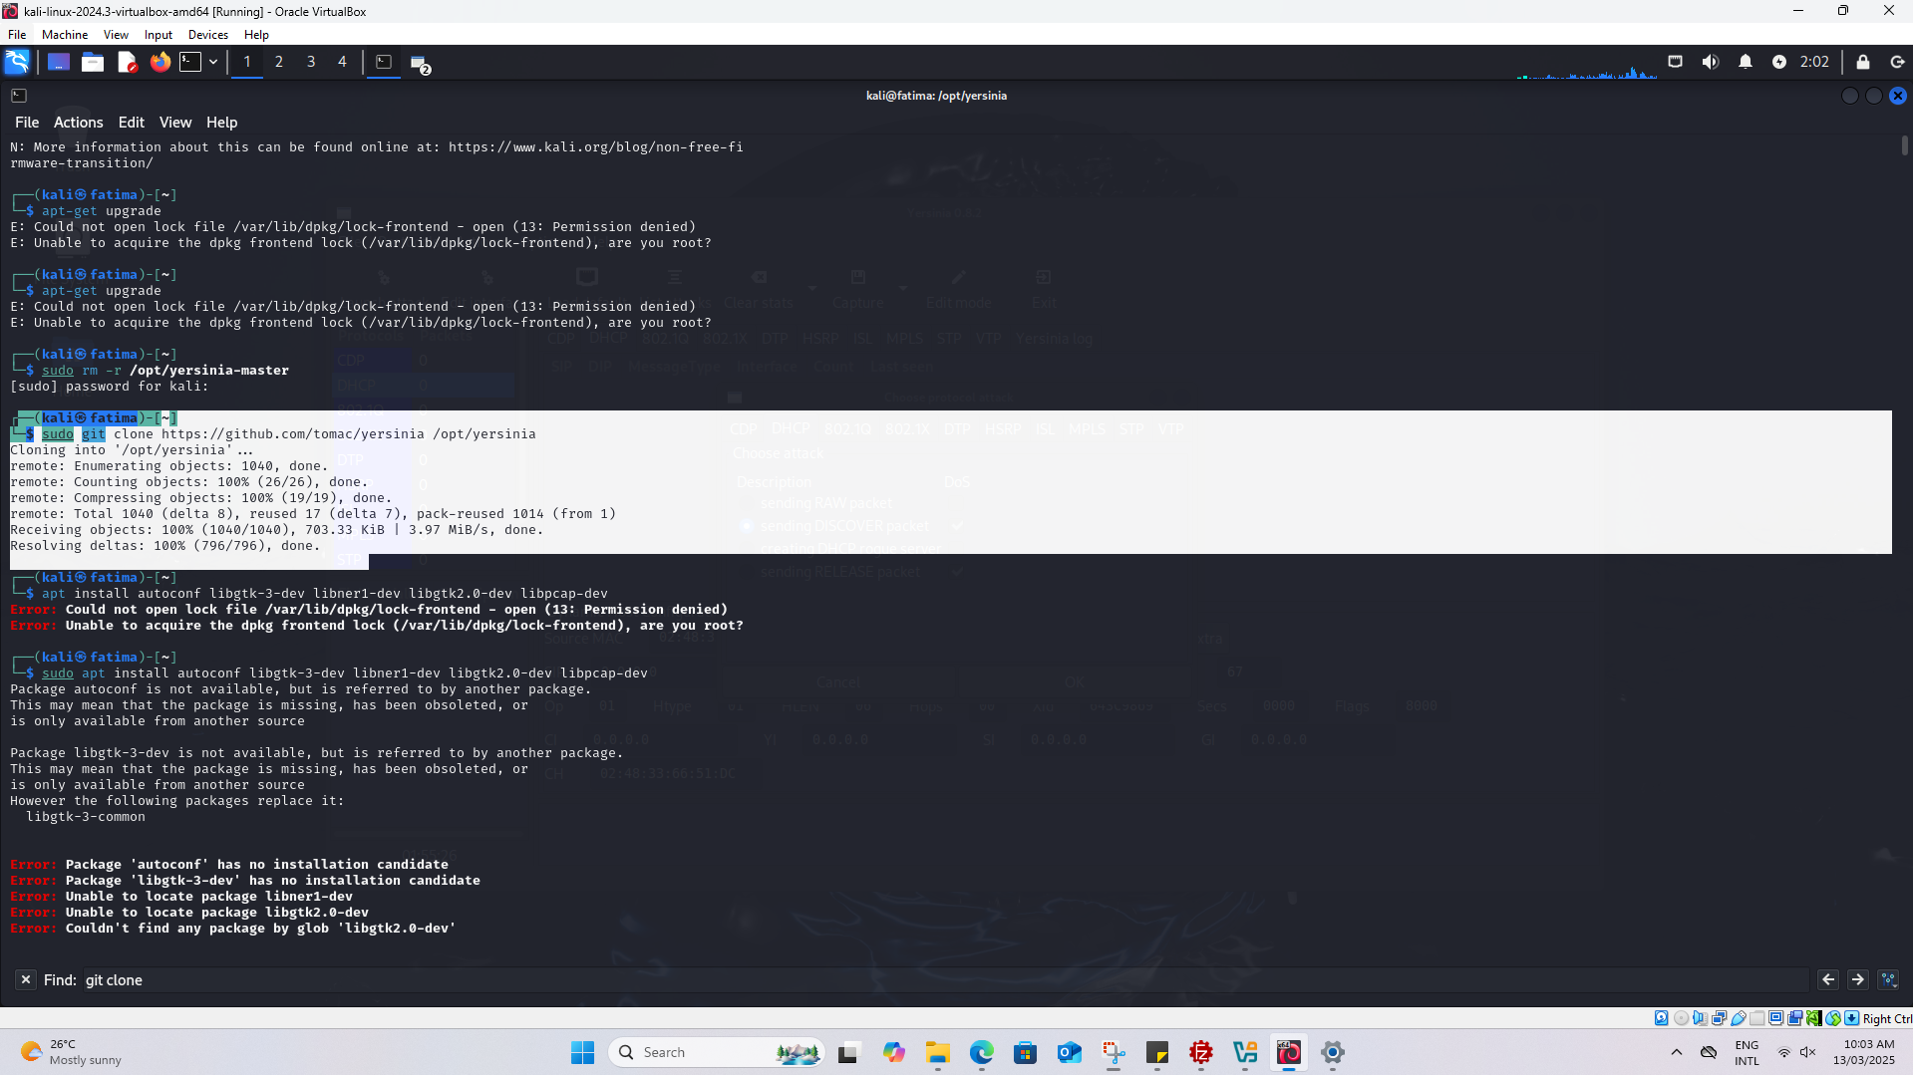

Figure 6. Git Cloning Yersinia

> apt install autoconf libgtk-3-dev libnet1-dev libgtk2.0-dev libpcap-dev

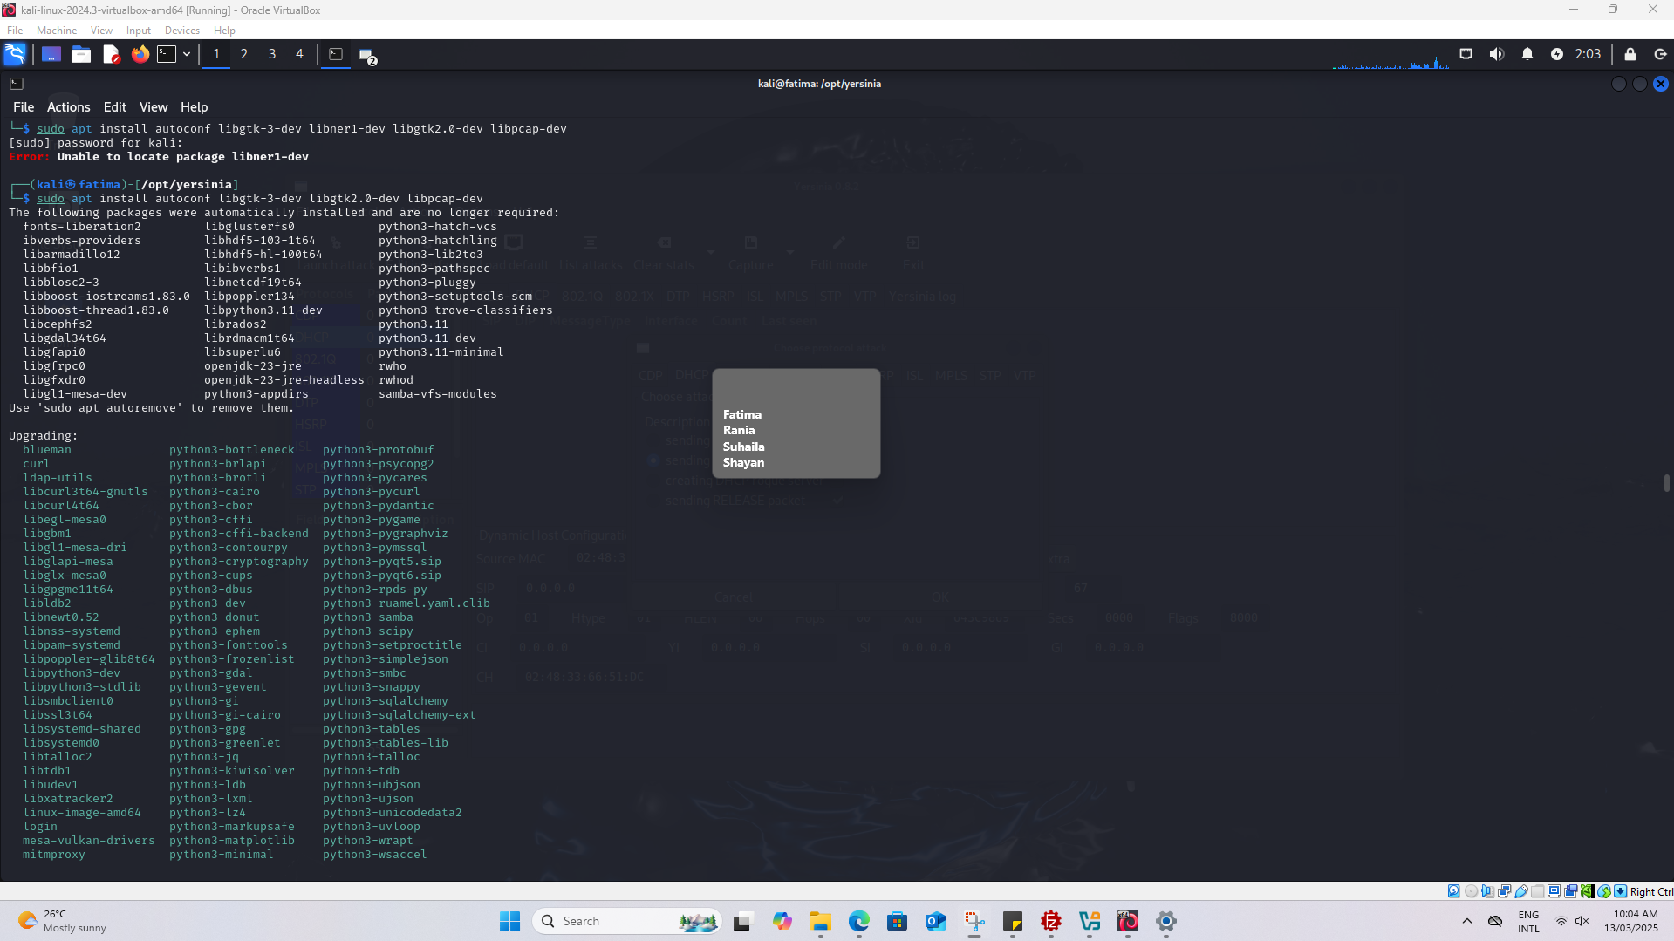

Figure 7. Installing Libraries for Yersinia

>cd /opt/yersinia

>sudo ./autogen.sh

Figure 8. Automating the Build Process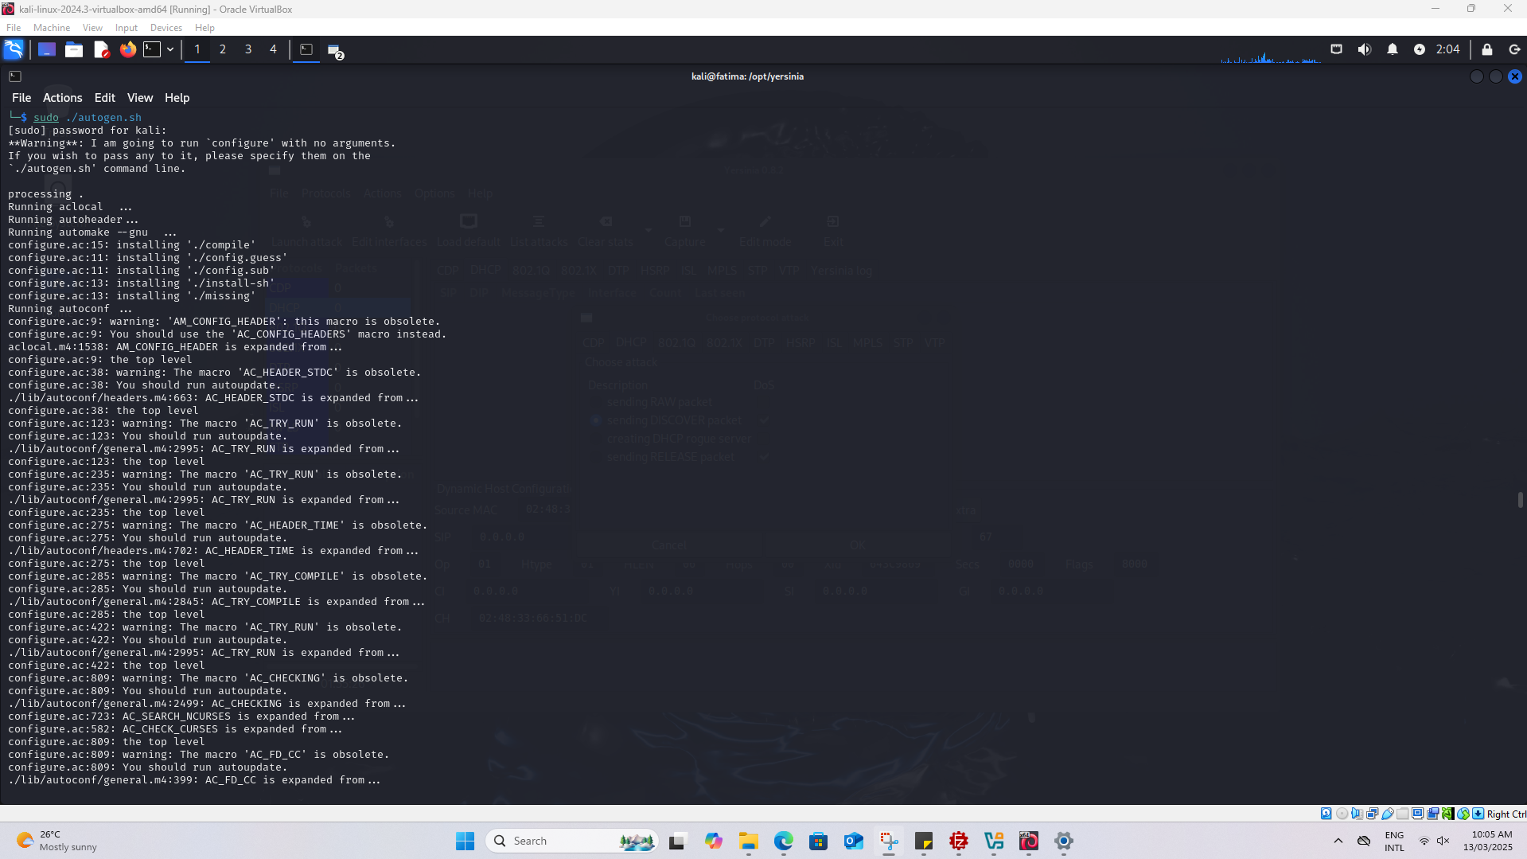

>sudo ./configure

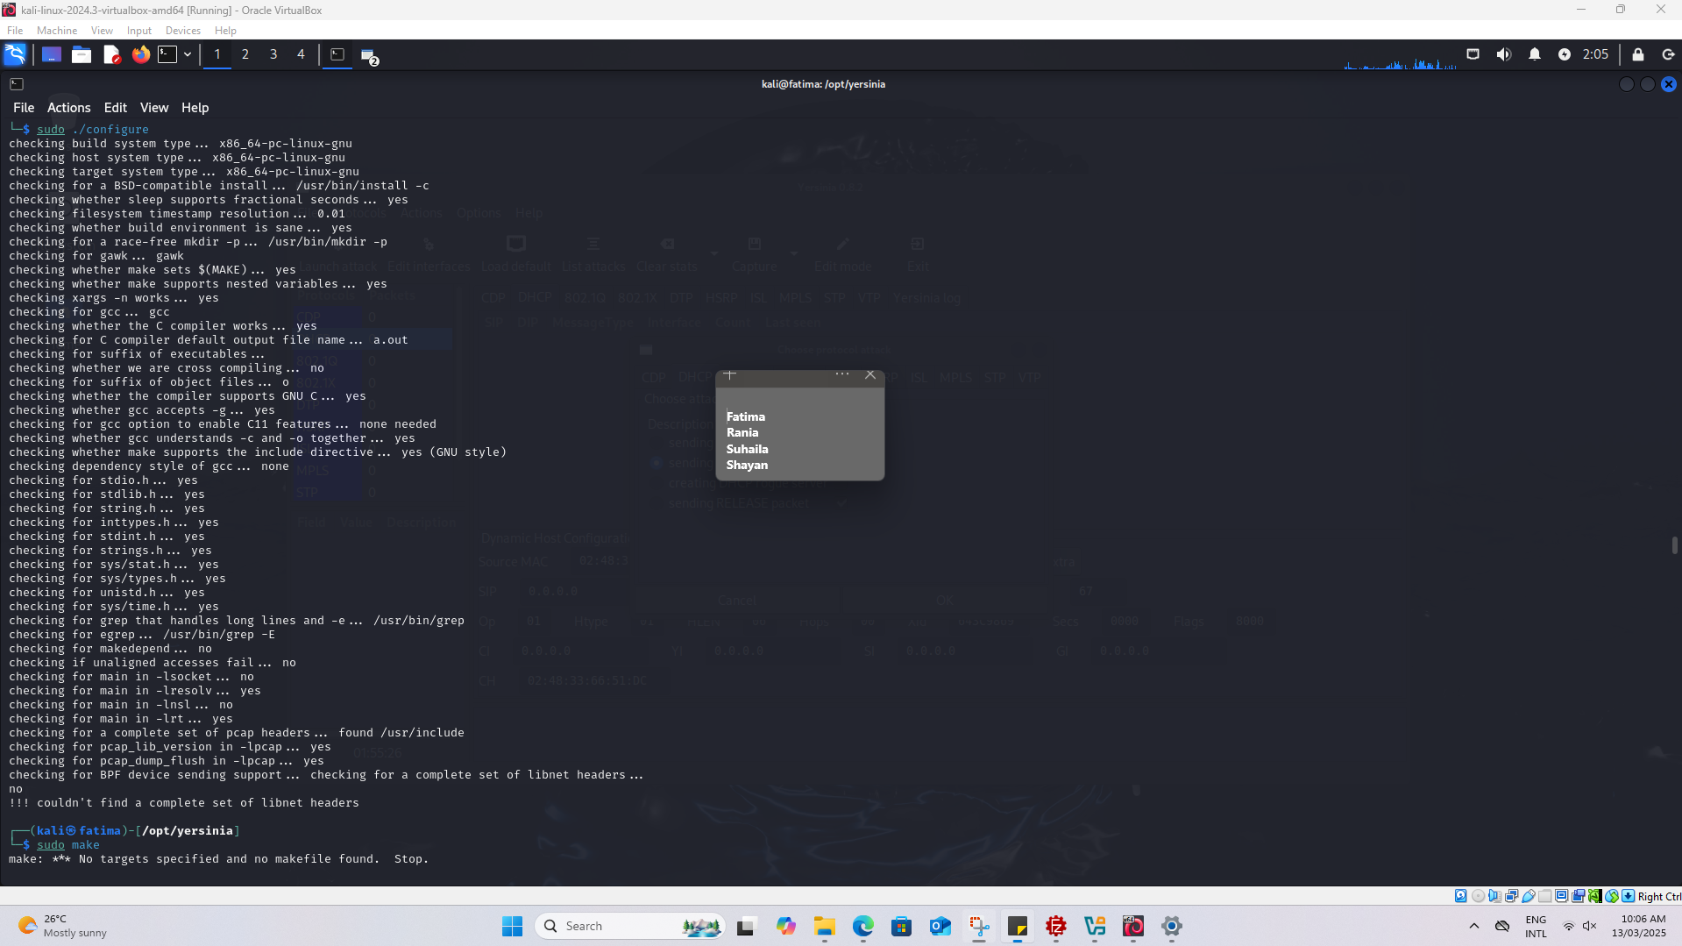

Figure 9. Compiling the Software

>sudo make

>sudo make install

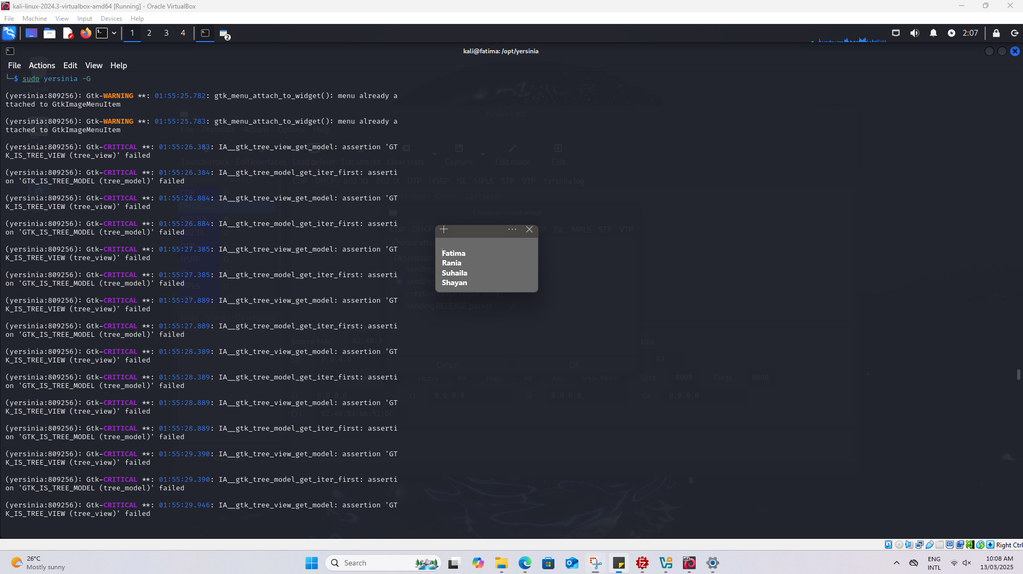

Figure 10. Starting the Yersinia

1. With this tool, you will overwhelm the legitimate DHCP service on the router with DHCP DISCOVER packets, as can be seen in Figure.

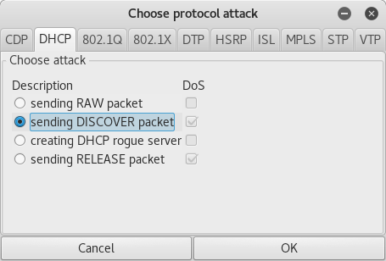  
**Sending DISCOVER Packets Using Yersinia**

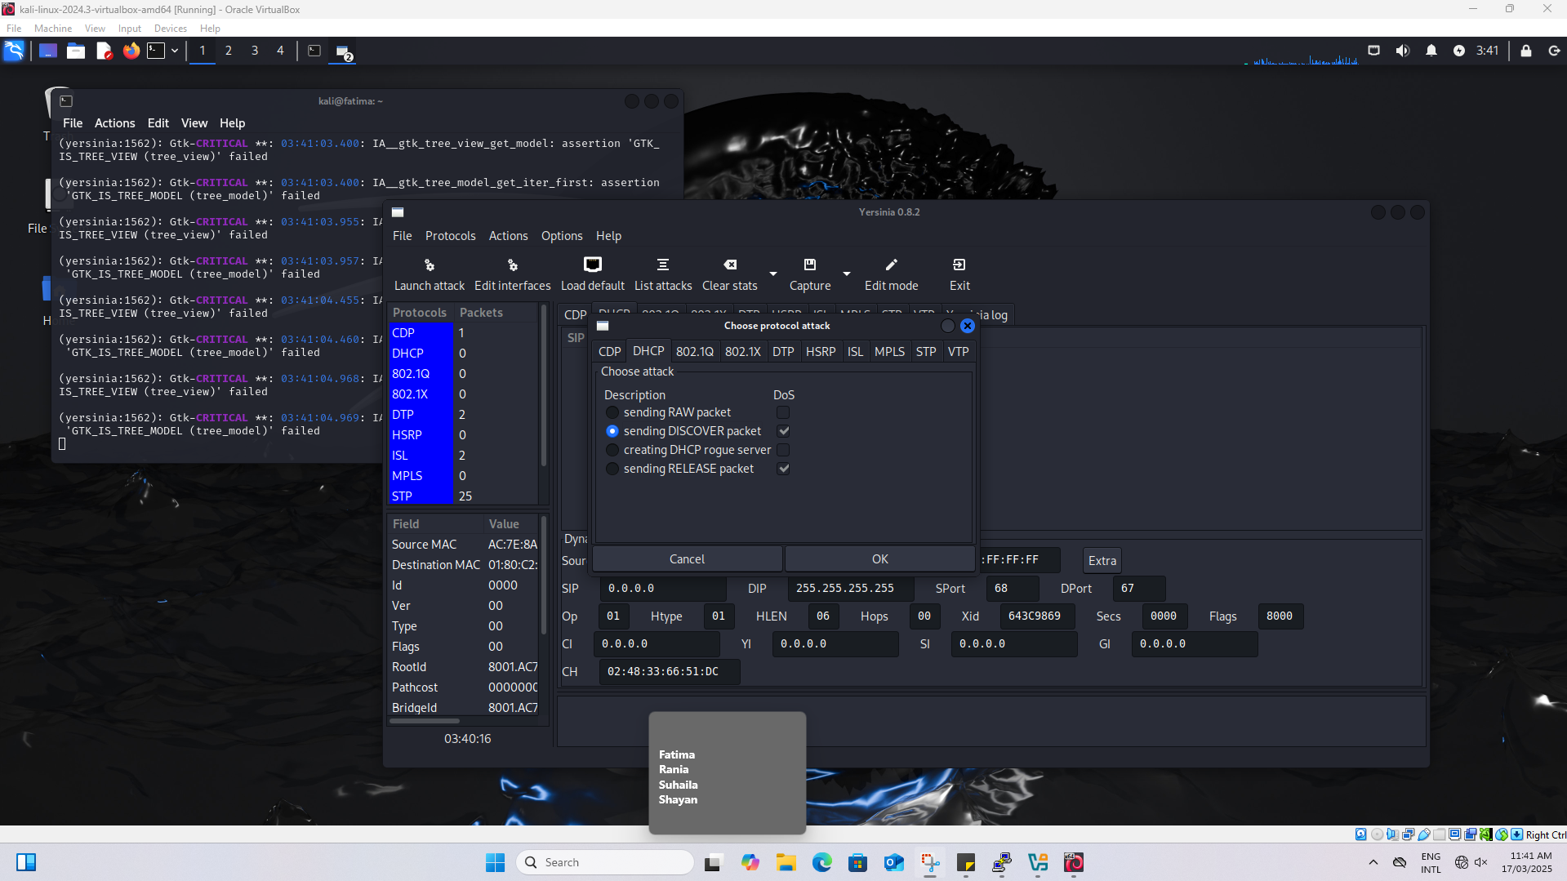

Figure 11. Sending Discover Packets

The attacker uses Yersinia to flood DHCP Discover packets towards the DHCP server when executing this attack. What happens is that it spends the pool of available DHCP leases until the DHCP server runs out of available IP addresses. When there is a new device that wants to connect it may fall in hands of an attacker that has gained control of the rogue DHCP server that can give malicious network configuration.

1. Check that the IP address range of the pool configured on the router is being depleted. Provide a screenshot

>show ip dhcp pool

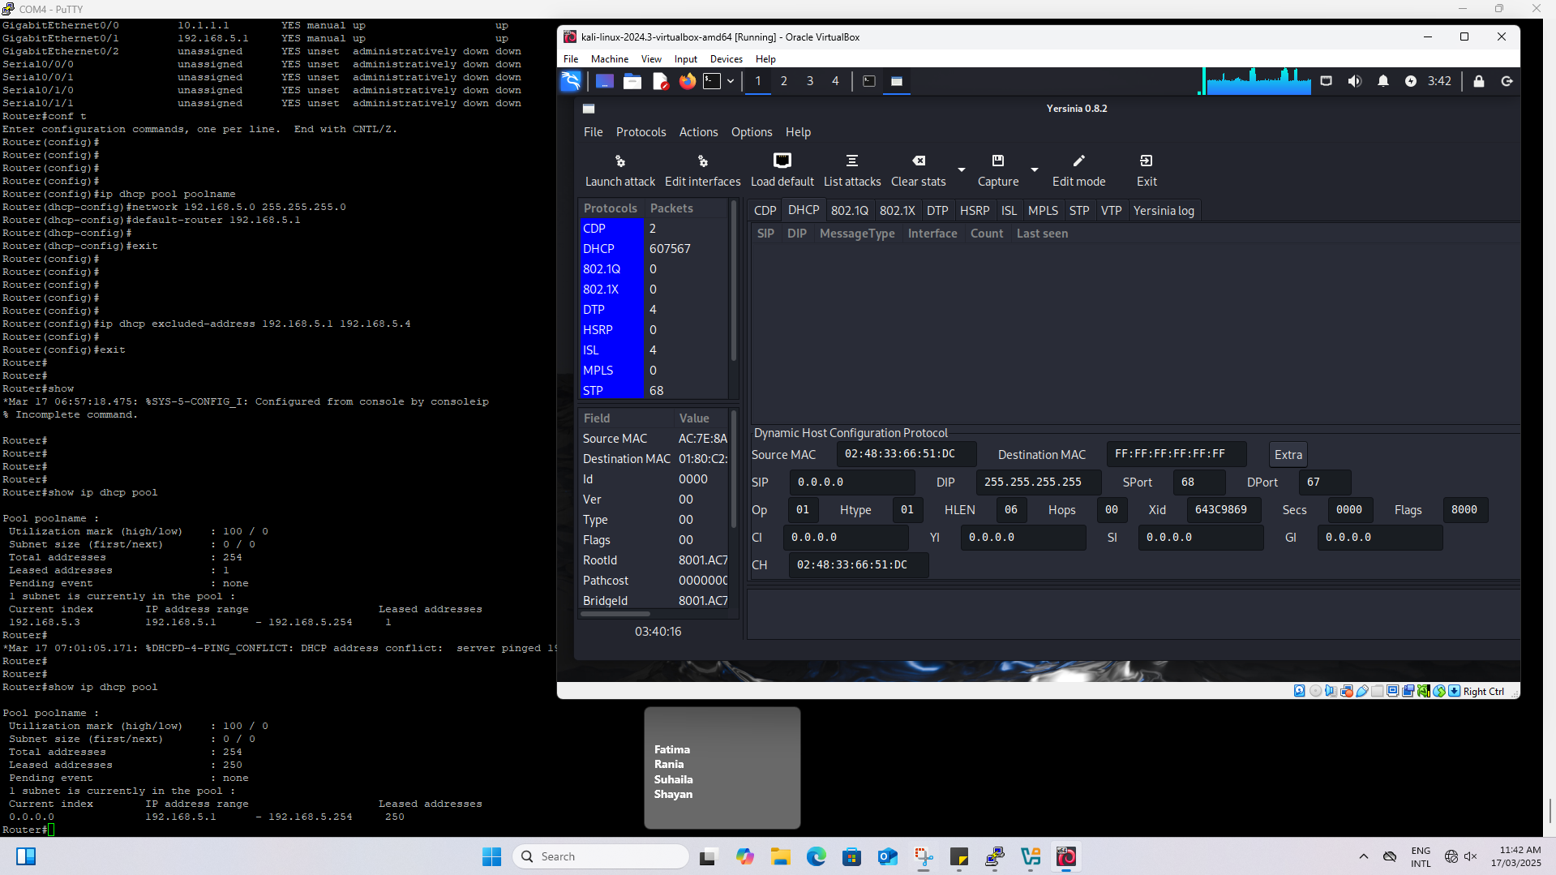

Figure 12. DHCP IP Addresses being Depleted

The DHCP pool holds 254 available IP addresses where 250 of them have distributed leases. This shows that these IP addresses that have been depleted have almost run out of IP addresses. The process affects the new devices who will face difficulty in trying to obtain an IP address which leads to network disruptions or allows rogue DHCP attacks to occur.

1. Setting Up the Rogue DHCP Server

Here you have 2 alternatives. You can either use Yersinia or Metasploit.

* 1. Yersinia tool to set rogue server.

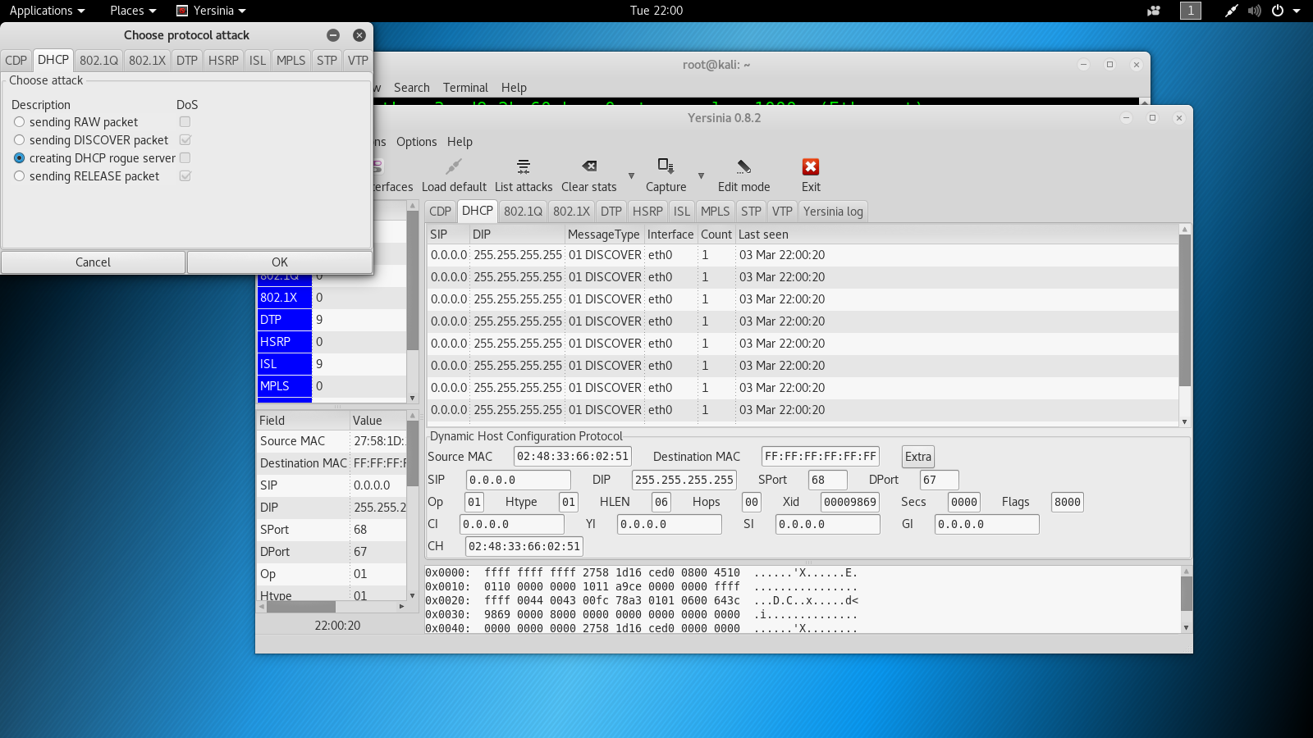  
**Creating DHCP Rogue Server Using Yersinia**

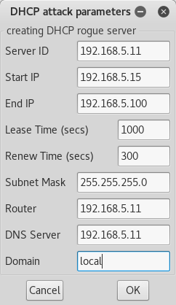

**Adding Rogue DHCP Server Parameters in Yersinia**

* 1. Metasploit to set rogue server.
* use auxiliary/server/dhcp
* set srvhost 192.168.5.11
* set netmask 255.255.255.0
* set dnsserver 192.168.5.11
* options
* run

Now that we have setup a rouge DHCP server, which gives the **IP address of the attacker’s machine as the GW**. Client PC’s DHCP server will be automatically changed to 192.168.5.11. Once you successfully set the attacker machine as the DHCP server, the client will request DHCP-related queries from the attacker machine. To do this you need to renew the IP of the client.

>ipconfig /renew

Provide a screenshot

**We used Ettercap Instead of Yersinia and Metasploit**

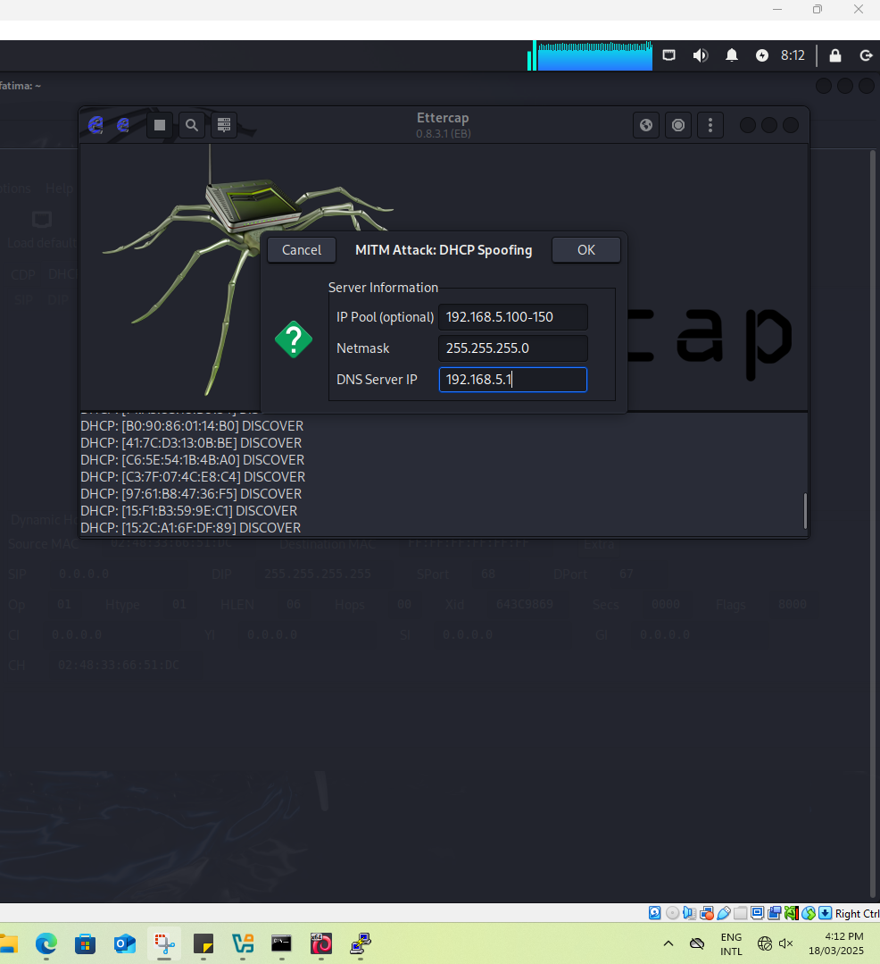

Figure 13. DHCP Spoofing

The attacker uses ettercap to execute the dhcp spoofing attack. The IP pool 192.168.5.100 - 192.168.5.150 is assigned by the rogue dhcp server. Setting the dns server ip to 192.168.5.1 makes sure that the victim will resolve the domain names through the attacker’s control.

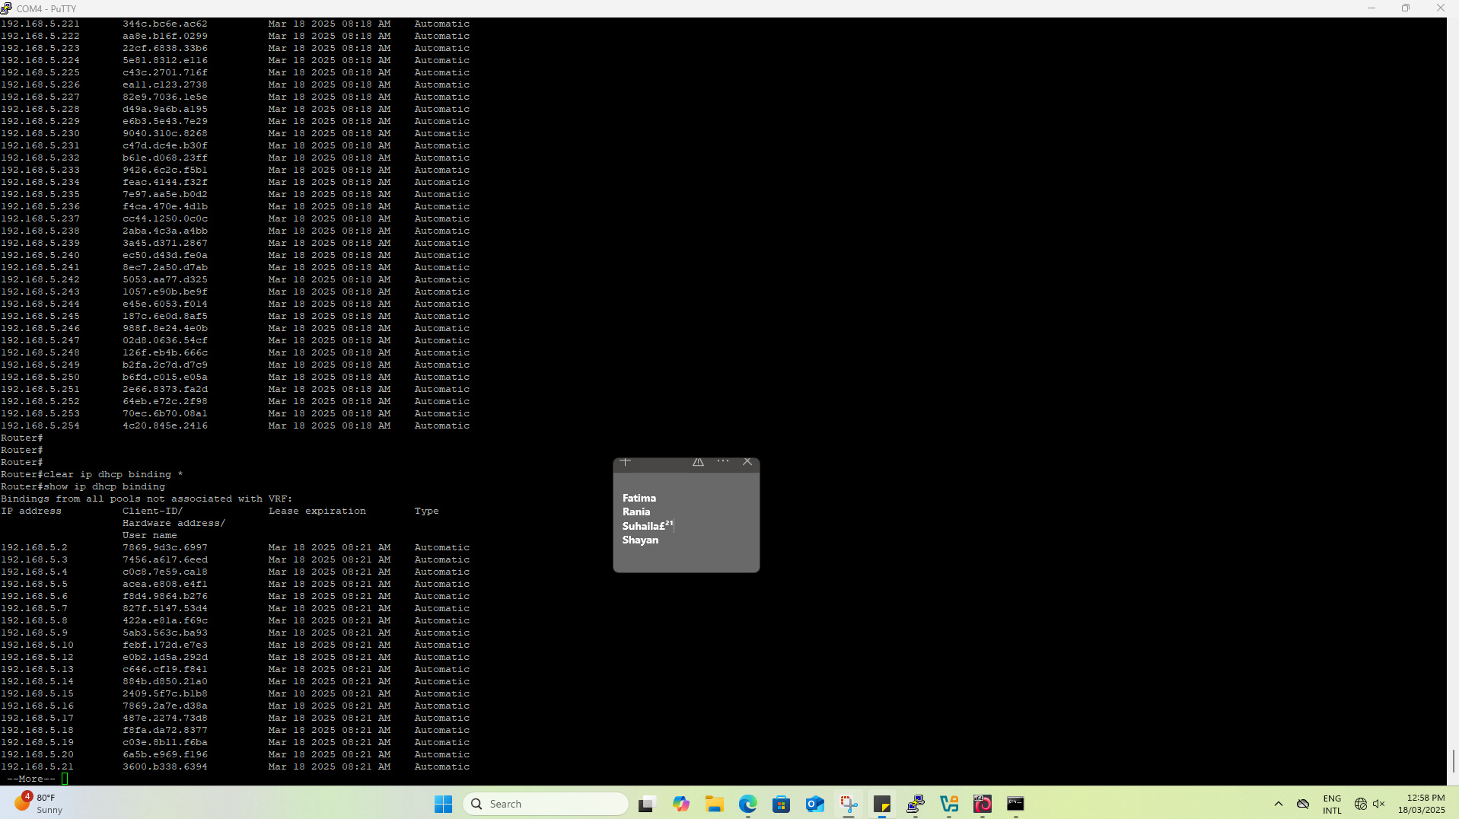

Figure 14. Clearing IP DHCP Binding

In this figure we are Clearing DHCP Bindings which means: The router won’t remember which MAC address is tied to which IP so that a fresh DHCP request by the client (victim) will not be limited to the IP address that was previously assigned and thus step is very important so the attack can work successfully with noticing that the Ip address on the client machine has changed

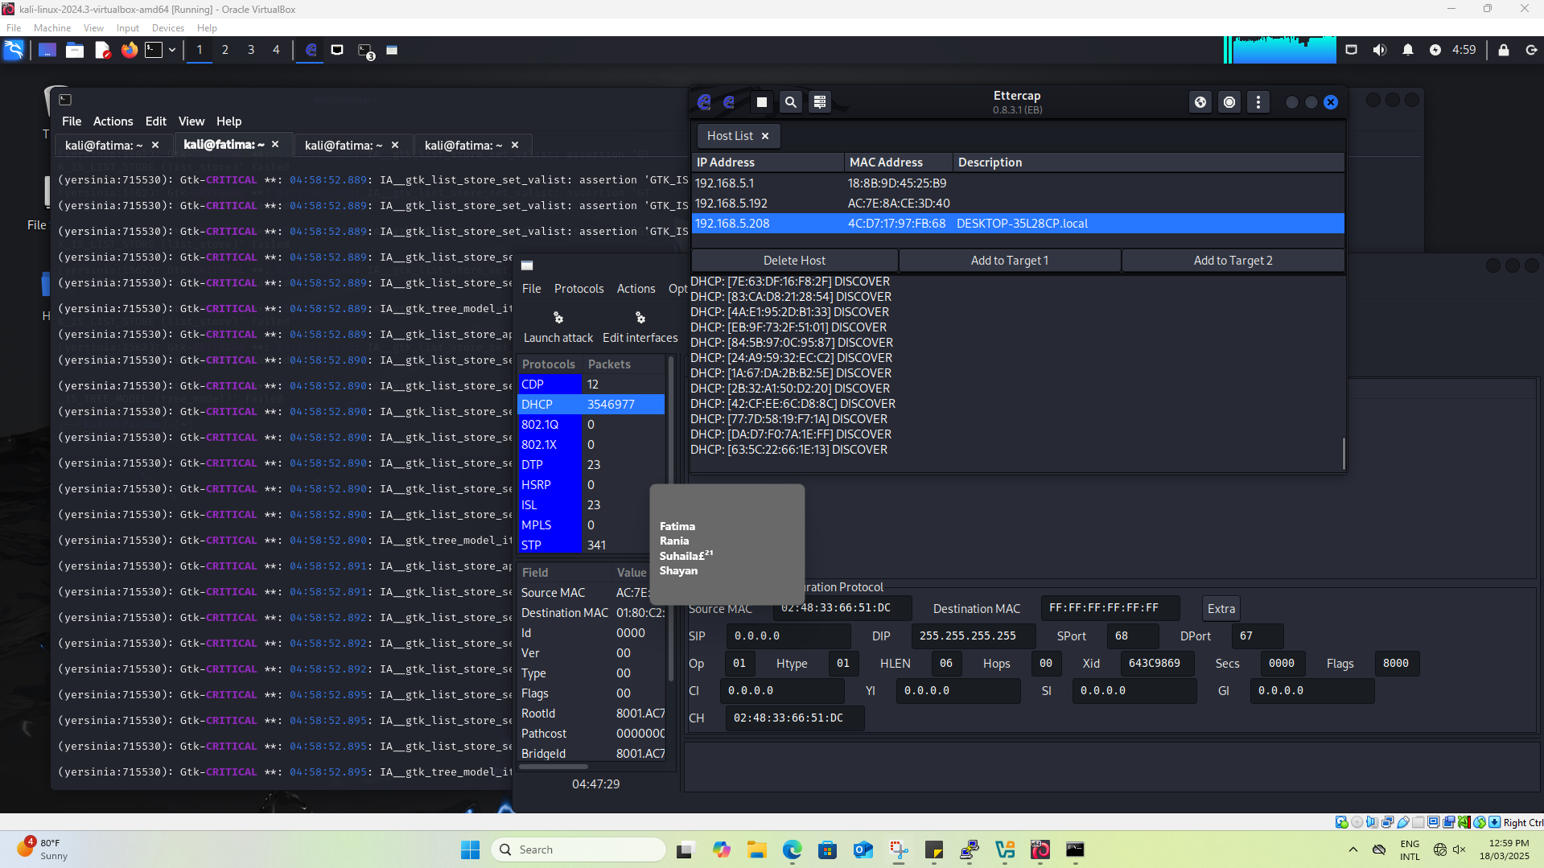

Figure 15. DHCP Rogue Server Using Ettercap

The attacker monitors the dhcp traffic using ettercap. The attacker can see victim ip addresses and mac addresses. This step shows that the attacker is actively poisoning the network by intercepting dhcp requests.

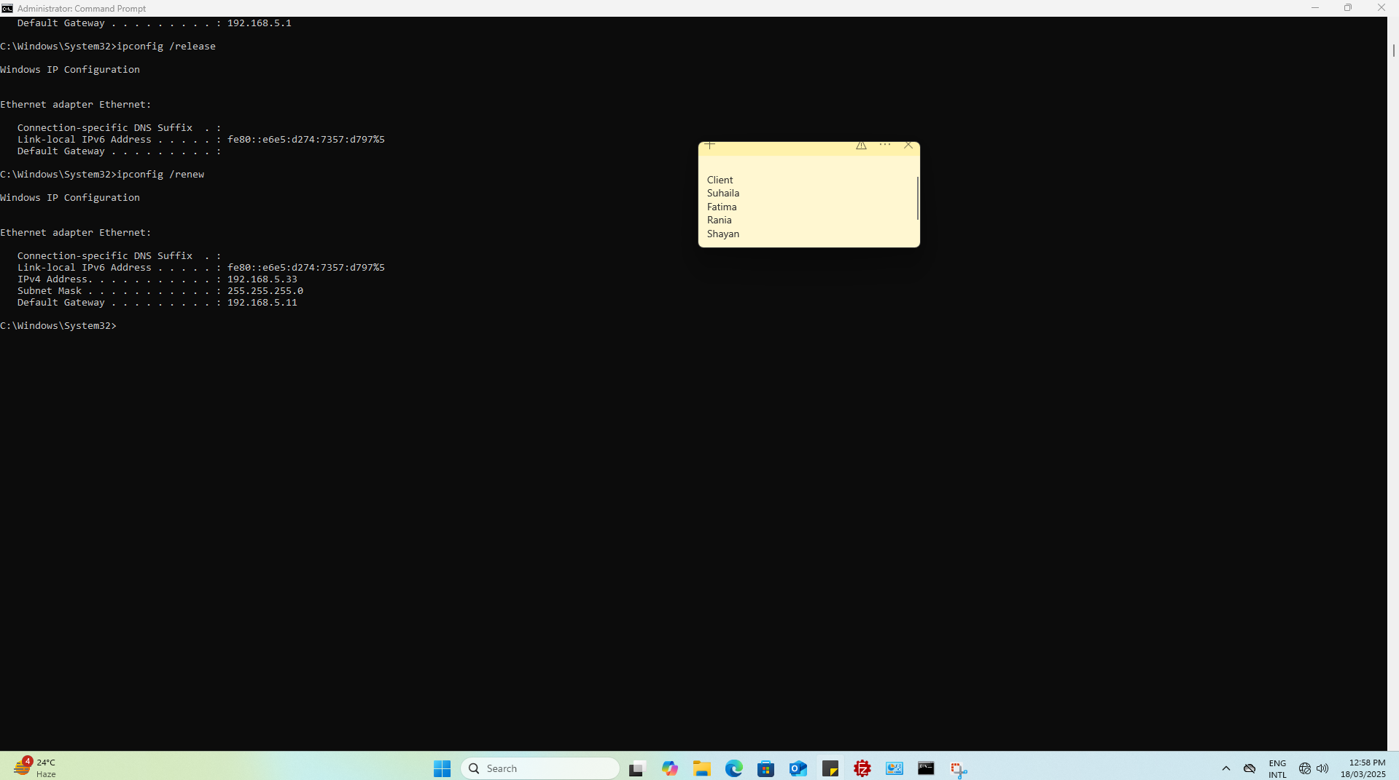 Figure 16. Verification of the Attack

Victim machine runs the command ipconfig /release to release its current IP address and ipconfig /renew to get a new IP address from the dhcp. The new default gateway on the victims machine is 192.168.5.11 which is the attacker’s machine. This shows that the MITM attack is working and now the internet traffic is routed through the attacker.

Original Ip address given from DHCP was 192.168.5.208

1. DNS Spoofing & Phishing Web Server – In the phishing server, use SEToolkit to clone the google.com:

1- Open “setoolkit” in and agree the agreement.

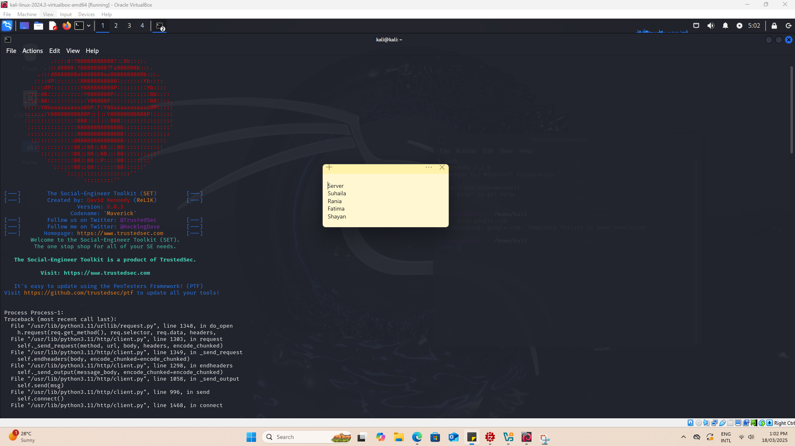

Figure 17. Running setoolkit

2- Select “1” > “2” > “3” and

3- Select “2” for cloning the website.

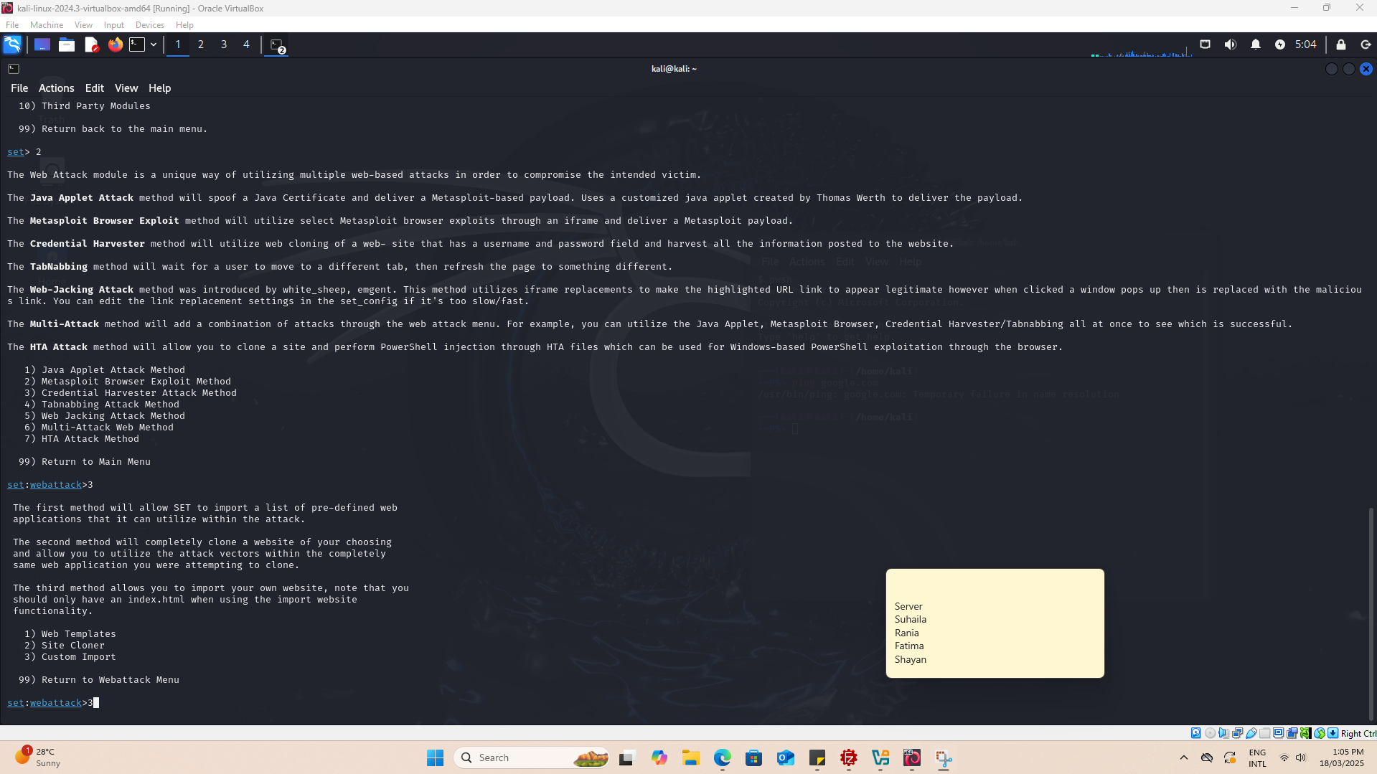

Figure 18. Site Cloning

The attacker is using SETtoolkit to generate a phishing website. The attack method selected is “Web Cloning”, which creates a fake version of a website.

4- Type server IP address (hit “enter”). This is our web server. It will show us the clone of the fraud website. (10.1.1.5)

Figure 19. Using Server IP Address to a fraud website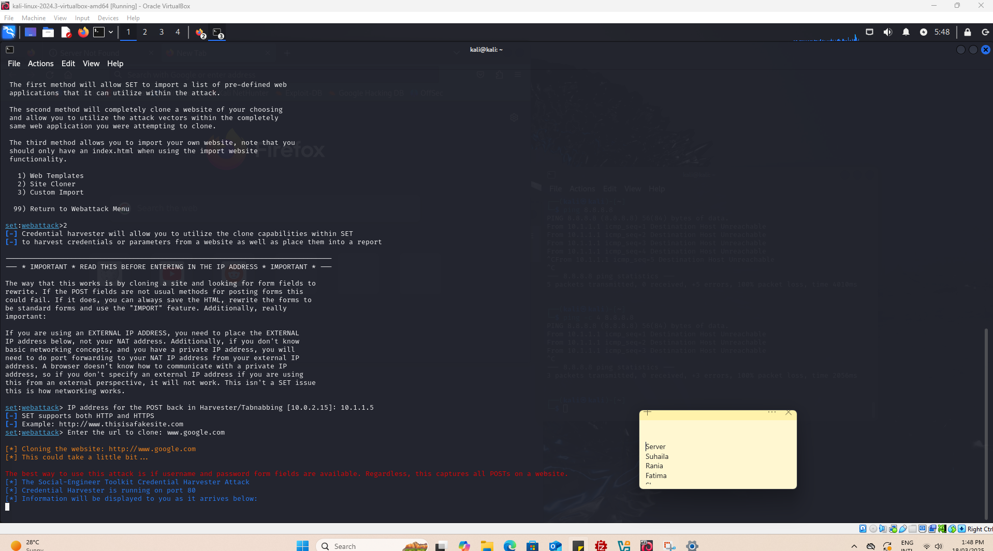

‘[www.google.com](http://www.google.com)’ is the url chosen for the fraud site. Since this is a credential harvester attack any data entered on the clone site will be captured.,

1. Type a website URI “www.google.com”. If this website does not work you can also use: [www.google.com](http://www.google.com)

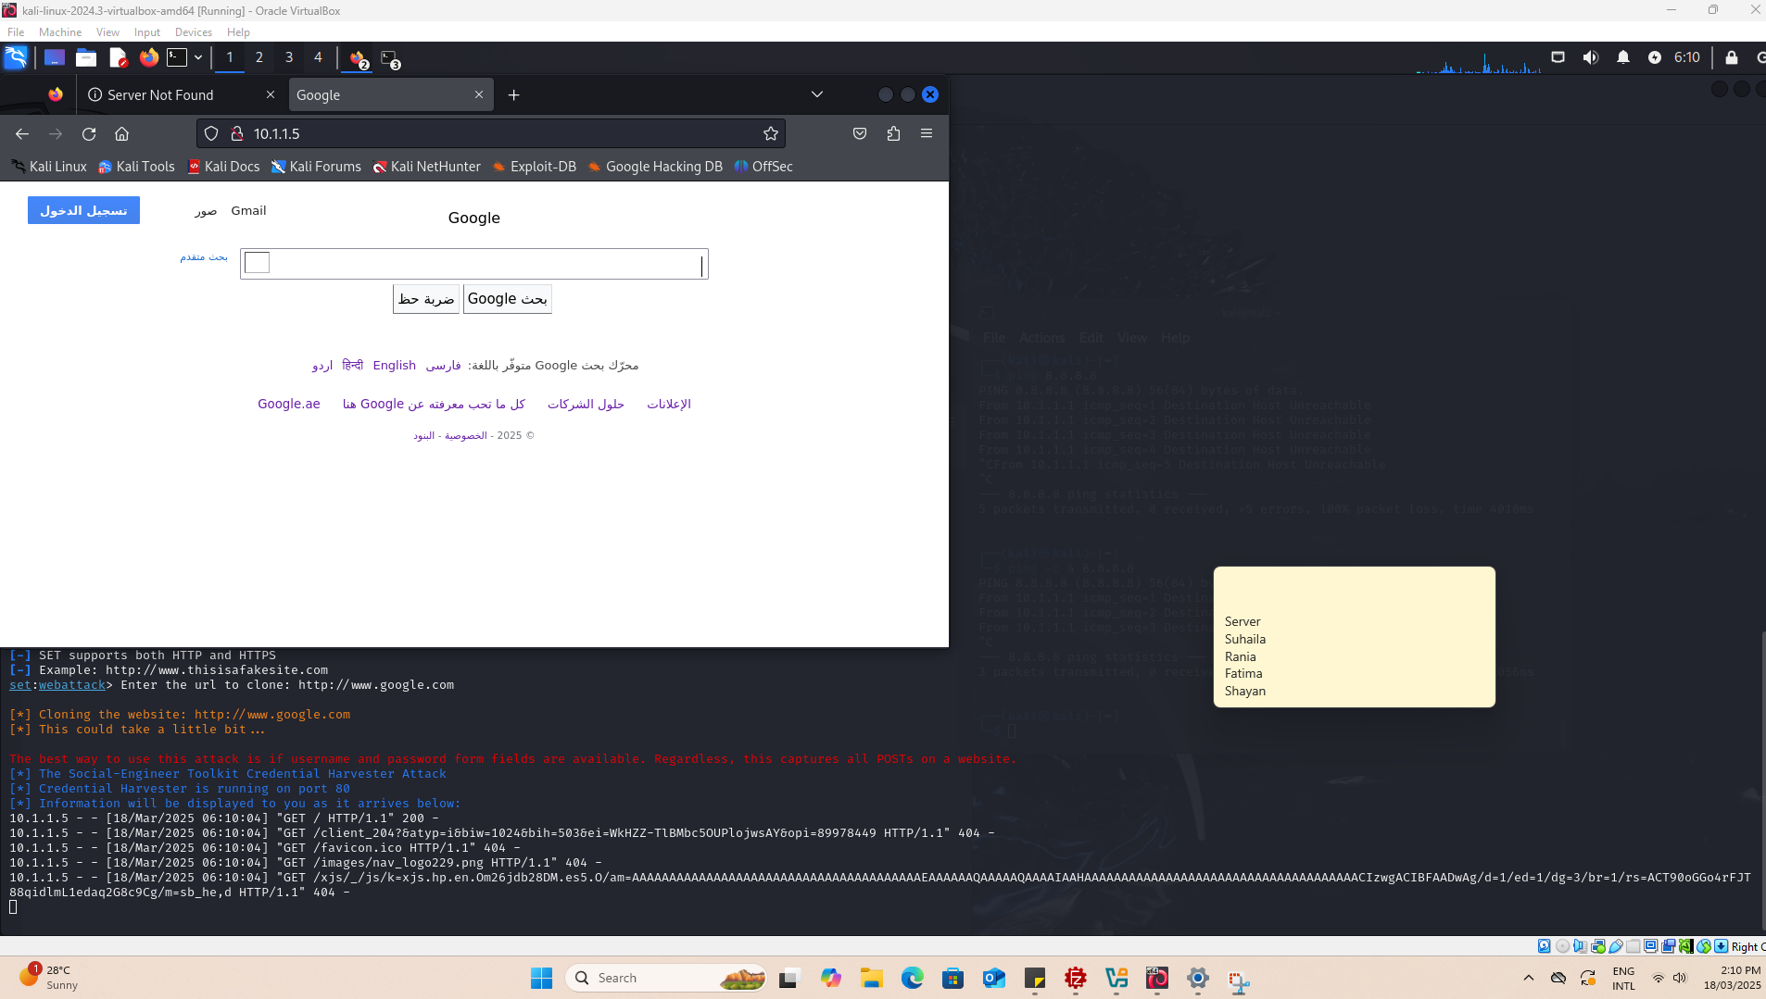

Figure 2o. Verification of the Site Cloning

The cloned version of google.com can be seen. The url of the site tells that it is being hosted locally on the web server machine. In the logs there are multiple GET requests which shows that the cloned page is loading resources like favicon.ico and JavaScript files.

1. After this, run the Metasploit module fakedns on the attacker machine with certain parameters that allow the DNS to resolve the domain [www.google.com](http://www.google.com) to the phishing web server.

* use auxiliary/server/fakedns
* set SRVHOST 192.168.5.11
* set TARGETHOST 10.1.1.5
* set TARGETACTION FAKE
* set TARGETDOMAIN [www.google.com](http://www.google.com)
* set SRVPORT 53
* show options

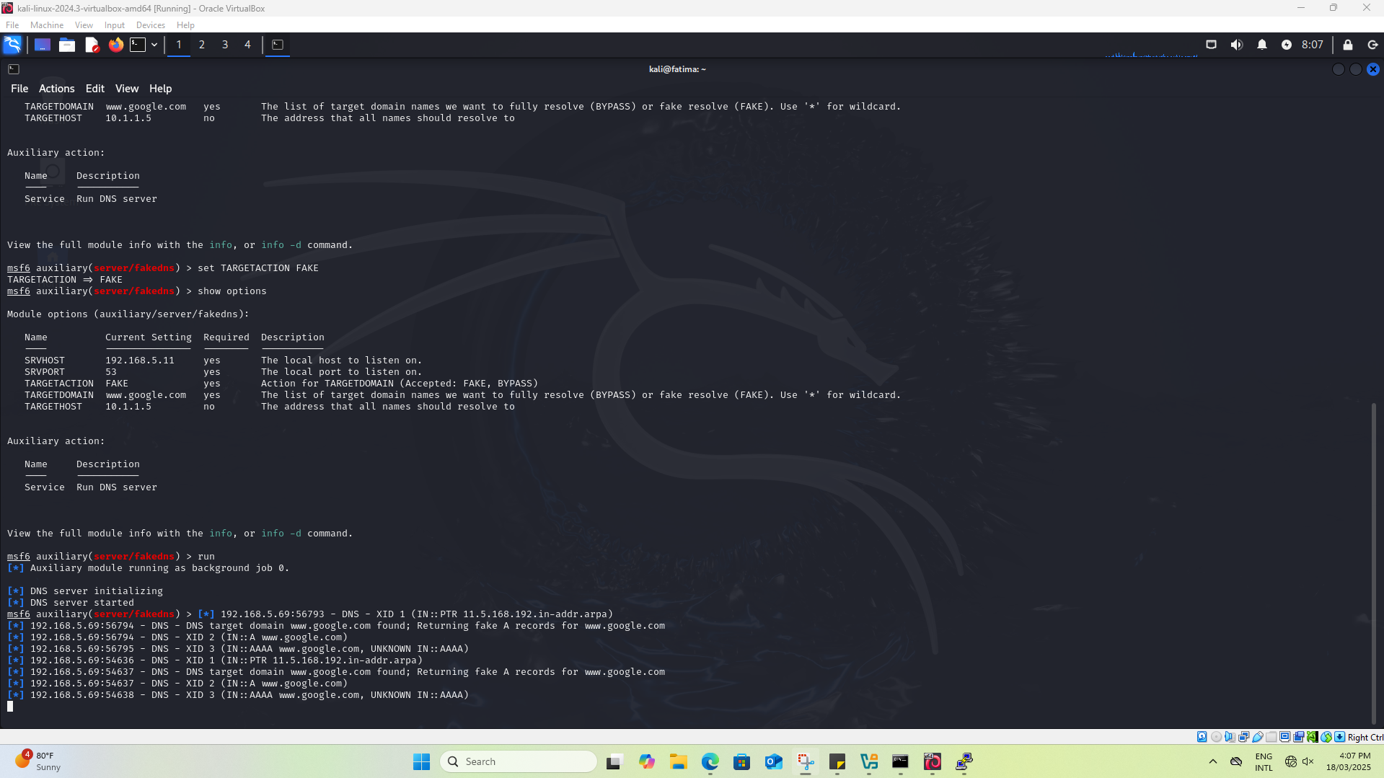

Figure 21. Metasploit fakedns

The attacker sets TARGETACTION to FAKE, meaning any DNS query for a specified domain will return a spoofed IP. The attacker is now able to redirect users to a phishing site without their knowledge.

Verify with “dig [www.google.com](http://www.google.com)” from Attacker. You need to delete browser cache in Phishing Server as well.

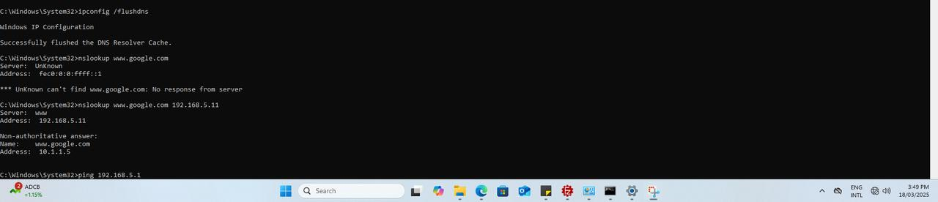

Figure 22. Verification

Through the Client machine the nslookup was used to confirm that DNS spoofing is working, using nslookup www.google.com it shows the queried DNS system identifies itself as "www" while using 192.168.5.11 as its IP address which indicates that the rogue DNS server is operated by the attacker machine and the IP address redirects to the phishing server with IP address 10.1.1.5 instead of Google's real IP address.

**PROBLEMS/ISSUES FACED**

We faced an issue while trying to download yersinia. This was because the attacker machine’s VM was set on bridged mode Ethernet .We fixed it by changing the Ethernet to Wi-fi connection and placed the IP address of the PC into the VM. Furthermore, during the DHCP spoofing attack using Metasploit’s fakedns module, we encountered an issue where the victim machine's IP address was not changing, even after attempting to release and renew the IP configuration . This problem occurred because the router was binding the IP address to the victim’s MAC address, preventing the DHCP lease from being fully released.To resolve this issue, we had to manually clear the DHCP IP binding on the router.

# MITIGATION TECHNIQUES

## Port Security

The following steps can be taken to prevent DHCP Starvation attacks.

**Switch1(config)# int fa0/1  
 Switch1(config-if)# switchport mode access  
 Switch1(config-if)# switchport port-security max 3  
 Switch1(config-if)# switchport port-security mac-address sticky**

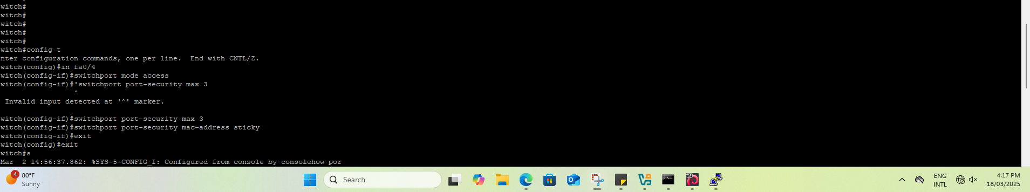Figure 23. Mitigation of DHCP Starvation Attack

The figure above shows that the port is set to access mode meaning it will only allow traffic from a single VLAN. The “switchport port-security max 3” command limits the port to a maximum of three mac addresses at a time. The “switchport port-security mac-address sticky” command enables sticky MAC addresses. This will allow the switch to dynamically learn the first three MAC addresses that connect and lock them in the configuration.

All of this prevents unauthorized devices from connecting to the network via this switch port. It limits MAC address spoofing and it protects against dhcp spoofing.

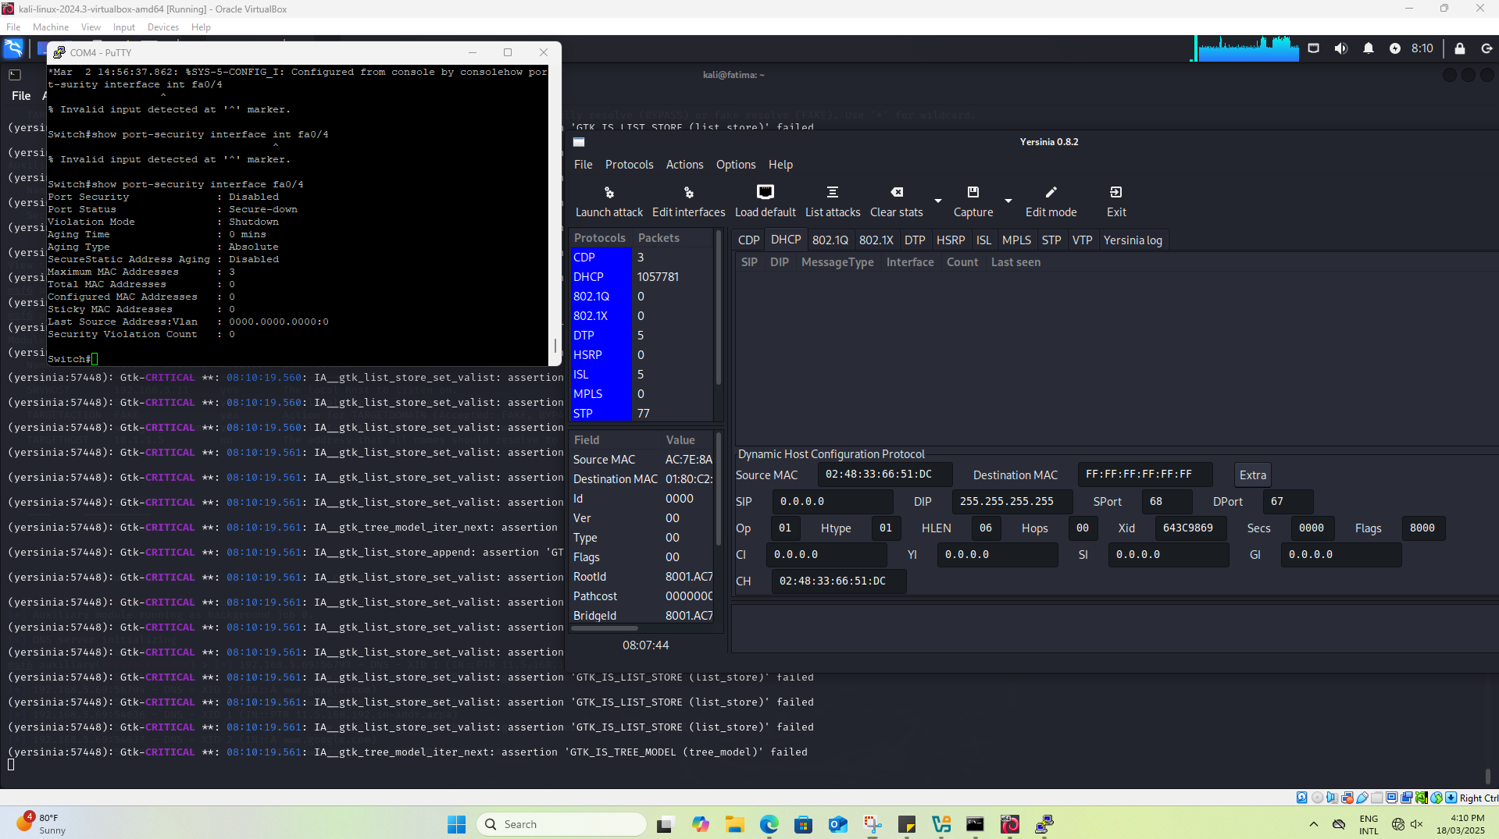

Figure 24. Verification of the Mitigation

In the screenshot above, the command show port-security interface fa0/4 is executed to verify the security settings on FastEthernet 0/4. The output shows that the port is secure and the maximum mac addresses allowed is 3. Sticky MAC address learning is also enabled and currently its 0.

Pros:

1. It stops other machines (attackers) from being able to plug into the infrastructure. The attacker would have to search to find a port that has not been configured correctly to carry out attacks.
2. Can audit logs to determine if empty ports are turned on or off.
3. Can alert the administrator more quickly to rogue devices being plugged into the infrastructure.
4. Not a perfect solution but should be part of your defense in depth solution, it's not meant to be a "stand alone" solution.

The cons:

The security measure Port Security helps block unauthorized devices from joining the network however its scalability is restricted and attackers can avoid this protection by using MAC address spoofing. It also offers no security to authorized devices currently present on the network and demands high management involvement and may generate false alerts from logical MAC address modifications or shared interface usage. The operations of Port Security occur at Layer 2 without capabilitty to defend against attacks affecting levels beyond that such as IP spoofing or DNS poisoning.

## DHCP Snooping

The DHCP snooping feature on Cisco switches can be used to mitigate a DHCP server spoofing attack. With this mechanism **switch ports** may be configured in two different states, the **trusted or untrusted**.

**Switch1(config)# ip dhcp snooping vlan 1  
 Switch1(config)# int fa0/1  
 Switch1(config-if)# ip dhcp snooping trust  
 Switch1(config-if)# ip dhcp snooping limit rate 90**



Figure 25. Mitigation of DHCP server spoofing attack

Over here the command ip dhcp snooping trust marks the interface as a trusted dhcp source. Only the dhcp responses from this interface will be accepted. The limit rate is set to 90 packet per second. This is enough to prevent dhcp starvation attacks where an attacker floods the network with fake dhcp requests.

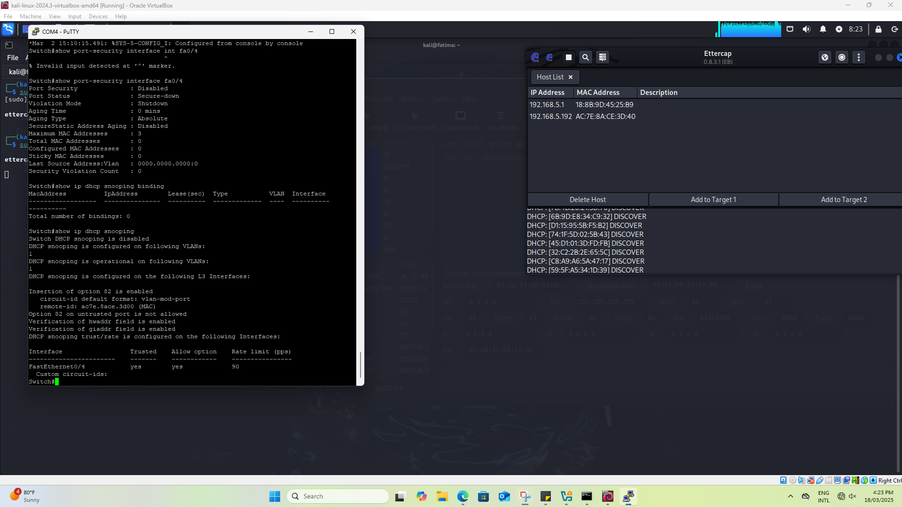

Figure 26. Verification of the Mitigation

The dhcp snooping feature can be enabled for the vlan 1. Then the port fa0/1 can be configured to have dhcp snooping trust. The rate limit feature can be set to 90 which indicates the number of packets per second. This feature will slow down or completely prevent a flood of spoofed DHCP requests thus preventing DHCP starvation attacks.

Pros:

DHCP is extremely important for mitigating DHCP related attacks like DHCP starvation.in network security, it helps differentiate between trusted and untrusted ports in order to allow only DHCP approved servers to provide IP addresses. This also helps protect users from man in the middle attacks and network hijacking attacks. With the use of DCHP snooping we are able to implement rate-limiting features that sets limits on the amount of DHCP requests that are processed on each port to defend networks against DHCP starvation attacks. Lastly, DHCP Snooping manages binding tables to track IP-MAC address connections which facilitates network troubleshooting activities.

Cons:

DHCP Snooping needs advanced configuration steps yet provides strong protection for DHCP attacks which can lead to misconfigurations in the network. As a result, implementation of this may lead to system performance degradation and creating potential errors by wrong DHCP configuration. DHCP snooping is also very limited as it only protects against DHCP only attacks. It can further block real DHCP traffic if the configuration is done in a very restrict manner

## IP Source Guard

IP Source Guard provides per-port IP traffic filtering.

Pros:

1. These measures provide a more stable network environment and help protect against intentional and unintentional events that can interfere with the proper operation of the network.

Cons:

1. Due to the administrative overhead required to leverage IP Source Guard, these measures are usually only implemented in smaller organizations.

## Implementing IEEE 802.1X Port Authentication

The 802.1X standard defines a **port-based access control and authentication** protocol that restricts unauthorized workstation from connecting to a LAN through publicly accessible switch ports and in turn acting as an authentication mechanism. The authentication server authenticates each workstation. Until the workstation is authenticated, 802.1X access control allows only Extensible Authentication Protocol over LAN (EAPOL) traffic through the port to which the workstation is connected. After authentication succeeds, normal traffic can pass through the port.

Pros:

1. 802.1x behavior and operations are highly prescribed and well-documented. A powerful and effective way to implement network access control, it has been widely deployed across the professional network enterprise landscape.
2. 802.1x detects entry to the network before the endpoint has an IP address which prevents any havoc in the network.

Cons:

1. **Configuration complexity**: 802.1x requires *individual* *switch port configuration* (pre-device-connection) and ongoing management attention which requires a lot of time
2. **Support & Cost**: Not all network appliances support 802.1x, such as many legacy and lower-end, commodity-priced switches. These will need to be replaced which becomes costly.
3. **Network design**: 802.1x requires a considered, up-front design approach. Network segmentation, VLAN design, and switch deployment will be impacted.

# CONCLUSION

For this lab we mimicked a DHCP and DNS spoofing attack. We also used phishing methods to hijack traffic on the network. We started the attack with DHCP spoofing by configuring a malicious DHCP to provide malicious DNS and gateway settings to victim machines. By using Yersinia, we were able to achieve dhcp starvation which let us exhaust the existing leases of the authentic DHCP server, forcing victims to use the attacker controlled DHCP. We then used Metasploit's fakedns module to spoof DNS responses, sending requests to www.google.com to a cloned phishing web page. This was done to demonstrate the vulnerability of MITM attacks. Furthermore, we also tested the utility of Ettercap in sniffing DHCP traffic and confirming victims were being hijacked. We ended the attack by enabling DHCP snooping and port security on the network switch, preventing malicious DHCP responses and limiting the excessive DHCP requests. This lab highlights the importance of securing network infrastructure against MITM, spoofing, and phishing attacks through proper security practices like DHCP snooping, static ARP entries, and authentication.

# REFERENCES

Pradana, D., & Budiman, A. (2021). The DHCP Snooping and DHCP Alert Method in Securing DHCP Server from DHCP Rogue Attack. *IJID (International Journal on Informatics for Development)*. <https://doi.org/10.14421/ijid.2021.2287>.

Garbis, J., & Chapman, J. (2021). Network Infrastructure. *Zero Trust Security*. <https://doi.org/10.1007/978-94-007-0862-4_3>.

Mukhtar, H., Salah, K., & Iraqi, Y. (2012). Mitigation of DHCP starvation attack. *Comput. Electr. Eng.*, 38, 1115-1128. <https://doi.org/10.1016/j.compeleceng.2012.06.005>.

Vollmer, T., & Manic, M. (2014). Cyber-Physical System Security With Deceptive Virtual Hosts for Industrial Control Networks. *IEEE Transactions on Industrial Informatics*, 10, 1337-1347. <https://doi.org/10.1109/TII.2014.2304633>.

Seyyar, M., Catak, F., & Gul, E. (2018). Detection of attack-targeted scans from the Apache HTTP Server access logs. *Applied Computing and Informatics*, 14, 28-36. <https://doi.org/10.1016/J.ACI.2017.04.002>.

Stepanov, P., Nikonova, G., Pavlyuchenko, T., & Soloviev, V. (2022). Features of Address Resolution Protocol Operation in Computer Networks. *Programmnaya Ingeneria*. <https://doi.org/10.17587/prin.13.211-218>.